|  |
| --- |
| **VLSI Lab** |
|  |
| **LABORATORY REPORT** |
| **Spring 2019** |



|  |  |  |  |  |
| --- | --- | --- | --- | --- |
| **LAB 10** | | | | |
| **Title of Lab Experiment : Layout VS Schematic of Digital Circuits on available CAD Tools** | | | | |
| **Engr. Rashid Karim** | | | | |
|  | | |  |  |
| ___________Kamran____________ | | | ____i140420___ | _A |
| STUDENT NAME | | | ROLL NO | SEC |
| Student’s signature and Submission Date: ______10/4/19______________ | | | | |
| ______________________________________ | | | | |
| LAB ENGINEER’S SIGNATURE & DATE | | | | |
|  | | | | |
| **MARKS AWARDED:**  /**10** | | | | |
| ________________________________________________________________ | | | | |
| **NATIONAL UNIVERSITY OF COMPUTER AND EMERGING SCIENCES (NUCES), ISLAMABAD** | | | | |
|  | | | | |
| **LAB:** | **10** | **Layout VS Schematic of Digital Circuits on available CAD Tools** | | | |

#### **Learning Objectives:**

a. Implimentation of Layout and Schematic of CMOS Inverter

b. Checking Layout VS Schematic of Inverter

#### **Equipment Required:**

Software : L-Edit , T-Spice , W-Edit , S-Edit, LVS

1. Lab Summary:

In this lab, we implemented the layout and schematic of inverter and simulated them individually. We then, compared the results of both using LVS software.

Task:

1. Layout Screenshot:

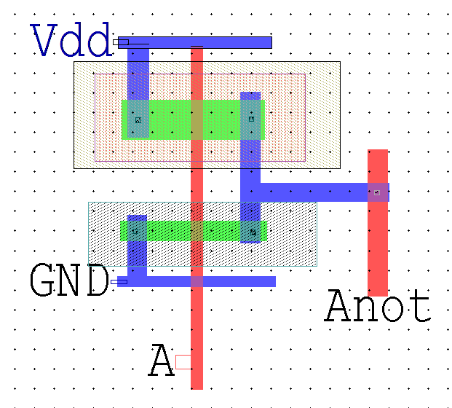

Spice code:

* Circuit Extracted by Tanner Research's L-Edit Version 13.00 / Extract Version 13.00 ;

* TDB File: C:\Users\i140420\Desktop\Kamran_VLSI_10_10-4\Layout\Inverter.tdb

* Cell: Cell0 Version 1.12

* Extract Definition File: ..\Generic_025.ext

* Extract Date and Time: 04/12/2019 - 10:10

.INCLUDE SpecialDevices.md

.lib "C:\Users\i140420\Desktop\Kamran_VLSI_10_10-4\Generic_025.lib" TT

.tran 10n 100n

v1 A Gnd PULSE (0 5 0 1n 1n 10n 20n)

v4 Vdd Gnd 5

.print tran v(A,Gnd) v(Anot,Gnd)

* NODE NAME ALIASES

* 3 = Anot (6.26 , 12.6)

* 4 = GND (-7.1 , 12.31)

* 5 = Vdd (-7.01 , 24.44)

* 6 = A (-3.81 , 8)

M1 Anot A GND 1 NMOS L=600n W=1u AD=3.23p PD=8.46u AS=3.56p PS=9.12u $ (-3.06 14.49 -2.46 15.49)

M2 Anot A Vdd 2 PMOS L=600n W=2u AD=6.3p PD=10.3u AS=6.98p PS=10.98u $ (-3.06 19.62 -2.46 21.62)

* Total Nodes: 6

* Total Elements: 2

* Total Number of Shorted Elements not written to the SPICE file: 0

* Output Generation Elapsed Time: 0.000 sec

* Total Extract Elapsed Time: 1.547 sec

.END

1. Schematic Screenshot:

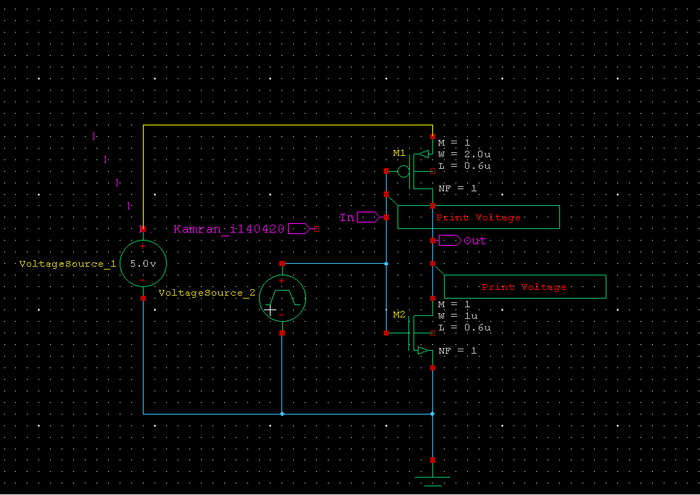

Spice Code:

* SPICE export by: SEDIT 13.00

* Export time: Fri Apr 12 10:13:44 2019

* Design: Inverter_schm

* Cell: Cell0

* View: view0

* Export as: top-level cell

* Export mode: hierarchical

* Exclude .model: no

* Exclude .end: no

* Expand paths: yes

* Wrap lines: no

* Root path: C:\Users\i140420\Desktop\Kamran_VLSI_10_10-4\Schematic\Inverter_schm

* Exclude global pins: no

* Control property name: SPICE

********* Simulation Settings - General section *********

.lib "C:\Users\i140420\Desktop\Kamran_VLSI_10_10-4\Tanner EDA\Tanner Tools v13.0\Libraries\Models\Generic_025.lib" TT

********* Simulation Settings - Parameters and SPICE Options *********

*-------- Devices: SPICE.ORDER > 0 --------

MM2 Out In Gnd N_3 NMOS W=1u L=600n AS=900f PS=3.8u AD=900f PD=3.8u

MM1 Out In N_2 N_1 PMOS W=2u L=600n AS=1.8p PS=5.8u AD=1.8p PD=5.8u

VVoltageSource_1 N_2 Gnd DC 5

VVoltageSource_2 In Gnd PULSE(0 5 0 1n 1n 10n 20n)

.PRINT TRAN V(In)

.PRINT TRAN V(Out)

********* Simulation Settings - Analysis section *********

.tran 10ns 100ns

********* Simulation Settings - Additional SPICE commands *********

.end

1. Output of LVS:

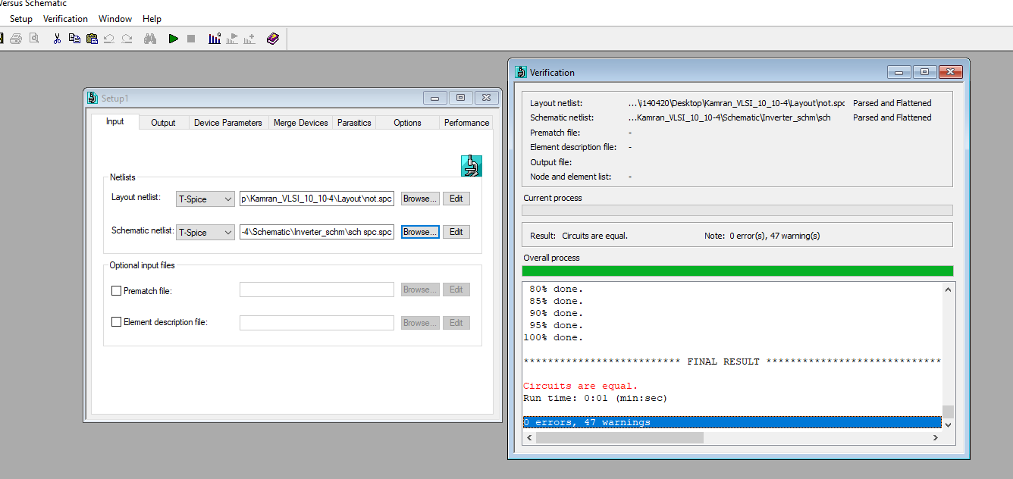

**Submission Declaration by the Student:**

In submitting this lab write-up to the Lab Engineer/Instructor, I hereby declare that:

I have performed all the practical work myself

* I have noted down actual measurements in this writeup from my own working
* I have written un-plagarised answers to various questions
* I have/have not obtained the desired objectives of the lab.

Reasons of not obtaining objectoves (if applicable):

___________________________________________________________________

___________________________________________________________________

___________________________________________________________________

___________________________

Student’s signature and Date

**Student Evaluation by the Lab Engineer:**

The Lab Engineer can separate this page from the writeup and keep it for his/her own record. It must be signed by the student with date on it.

* **Lab Work:** objectives achieved (correctness of measurements, calculations, answers to questions posed, conclusion) ________/30
* **Lab Writeup:** Neatness, appropriateness, intime submission ________/10
* **Troubleshooting:** Were the student able to troubleshoot his/her work when it was purposedly changed? ________/10
* **TOTAL:** ________/50

**Feedback on student behaviour:**

***Encircle*** your choice. -2 means poorest/worst/extremely inadequate/irrevlevant, 0 gives an average score, and +2 means best/most relevant/most adequate.

* Did the student join the lab at the start/remained in lab? -2 -1 0 1 2
* Did the student remain focused on his/her work during lab? -2 -1 0 1 2
* Rate student's behaviour with fellows/staff/Lab Engineer? -2 -1 0 1 2
* Did the student cause any distraction during the Lab? -2 -1 0 1 2
* Was the student found in any sort of plagiarism? -2 -1 0 1 2

Additional comments (if any) by the Lab Engineer:

__________________________________________________________________

___________________________________________________________________

___________________________________________________________________

___________________________________________________________________

___________________________

Lab Engineer’s signature and Date

**Student's feedback: [Separate this page; fill it; drop in the Drop Box.]**

* Providing feedback for every lab session is optional. No feedback means you are satisified
* The Lab Committee will consider only duly filled forms submitted within one week after the lab
* This feedabck is for LAB session: LAB Number: _____, Date: _____________________
* General (to provide feedback on a persistent practice/ocurrence in LABs).
* Your current CGPA is in the range 4.00 to 3.00/2.99 to 2.00/1.99 to 1.00/0.99 to 0.00

**This feedback is:**

* For a Particular
* Who conducted the LAB? __________________________________________________
* Actual Start time: _______________ Total Duration of Lab: _______________________
* Instruction Duration: _________________ Practical Duration: _____________________
* LAB writeup available before LAB? Yes/No with the Photocopier/in LAB/in SLATE
* Had the theory related to lab been covered in theory class? Yes/No

***Encircle*** your choice. -2 means poorest/worst/extremely inadequate/irrevlevant, 0 gives an average score, and +2 means best/most relevant/most adequate.

|  |  |  |  |  |  |  |  |
| --- | --- | --- | --- | --- | --- | --- | --- |
| **Instruction Session** | Was duration of instruction session adequate? | |  |  |  |  |  | | --- | --- | --- | --- | --- | | **-2** | **-1** | **0** | **+1** | **+2** | |
| How much did you understand about the practical? | |  |  |  |  |  | | --- | --- | --- | --- | --- | | **-2** | **-1** | **0** | **+1** | **+2** | |
| How much content was irrelevant to the practical? | |  |  |  |  |  | | --- | --- | --- | --- | --- | | **-2** | **-1** | **0** | **+1** | **+2** | |
| Did the instructor allowed Q/A and discussion? | |  |  |  |  |  | | --- | --- | --- | --- | --- | | **-2** | **-1** | **0** | **+1** | **+2** | |
| **Practical** | Did you get sufficient time for practical? | |  |  |  |  |  | | --- | --- | --- | --- | --- | | **-2** | **-1** | **0** | **+1** | **+2** | |
| **Lab**  **Engineer** | Presence in lab at all time? | |  |  |  |  |  | | --- | --- | --- | --- | --- | | **-2** | **-1** | **0** | **+1** | **+2** | |
| Ability to convey? | |  |  |  |  |  | | --- | --- | --- | --- | --- | | **-2** | **-1** | **0** | **+1** | **+2** | |
| Readiness to help during practical? | |  |  |  |  |  | | --- | --- | --- | --- | --- | | **-2** | **-1** | **0** | **+1** | **+2** | |
| Readiness to discuss theoretical aspects? | |  |  |  |  |  | | --- | --- | --- | --- | --- | | **-2** | **-1** | **0** | **+1** | **+2** | |
| Helps in troubleshooting? | |  |  |  |  |  | | --- | --- | --- | --- | --- | | **-2** | **-1** | **0** | **+1** | **+2** | |
| Guides hows & whys of troubleshooting? | |  |  |  |  |  | | --- | --- | --- | --- | --- | | **-2** | **-1** | **0** | **+1** | **+2** | |
| **Staff** | How friendly was the lab staff? | |  |  |  |  |  | | --- | --- | --- | --- | --- | | **-2** | **-1** | **0** | **+1** | **+2** | |
| Presence of staff throughout the lab session? | |  |  |  |  |  | | --- | --- | --- | --- | --- | | **-2** | **-1** | **0** | **+1** | **+2** | |
| Impact of availability of staff on your practical? | |  |  |  |  |  | | --- | --- | --- | --- | --- | | **-2** | **-1** | **0** | **+1** | **+2** | |
| **Equipment** | Performance of Electronic Instruments? | |  |  |  |  |  | | --- | --- | --- | --- | --- | | **-2** | **-1** | **0** | **+1** | **+2** | |
| Performance of Breadboard/experiment kit? | |  |  |  |  |  | | --- | --- | --- | --- | --- | | **-2** | **-1** | **0** | **+1** | **+2** | |
| Performance of circuit components esp. ICs? | |  |  |  |  |  | | --- | --- | --- | --- | --- | | **-2** | **-1** | **0** | **+1** | **+2** | |
| **Overall** | Your overall rating for the whole lab session? | |  |  |  |  |  | | --- | --- | --- | --- | --- | | **-2** | **-1** | **0** | **+1** | **+2** | |

Other comments: _________________________________________________________________

_________________________________________________________________

_________________________________________________________________